3.10.1 Use Case Diagram
The use case model for the Real-Time Trending Topic Detection System defines a single actor, the System User, representing any authenticated individual who accesses the system through the React-based web dashboard. Having registered and authenticated, the System User interacts with the system to monitor real-time trending topics detected from English and Somali tweets, to filter and search those topics by language, time range, and keyword, to inspect the representative content and historical trajectory of individual topics, to compare the performance of the three topic-modeling approaches evaluated for the study (BERTopic, Latent Dirichlet Allocation, and Non-negative Matrix Factorization), to export trend data for offline analysis, and to configure notification preferences for daily digests and sudden trend-spike alerts. Figure 3.2 presents the corrected use case diagram, and the ten use cases listed below were each verified directly against the implemented backend endpoints and frontend pages described in Chapter Three.
Use Cases (Actor: System User)
- Register and Authenticate — sign up, log in with email/username and password or Google OAuth, and optionally enable two-factor authentication.
- View Real-Time Trending Topics — view the ranked list of currently detected trending topics with keywords and trend scores.
- Filter Topics by Language (English or Somali) — restrict the displayed topics to English, Somali, or both.
- Filter Trends by Time Range — narrow topics and history to the last 24 hours, 7 days, 30 days, or a custom date range.
- Search Trends by Keyword — retrieve topics whose keyword representation matches a user-entered search term.
- View Topic Summary (Representative Tweets) — expand a topic to read its representative sample tweets.
- View Historical Trends — browse previously detected topics and their trend scores over time.
- Compare Topic Modeling Approaches (BERTopic, LDA, and NMF) — review coherence, diversity, and topic-count metrics across the three modeling approaches and the training-run evolution of the deployed model.
- Export Trend Data for Analysis — download the current trend selection as a CSV file or a printable PDF report.
- Manage Notification Preferences (Email Digests and Trend Spike Alerts) — opt in or out of daily email digests and sudden trend-spike email alerts.
Use Case Diagram
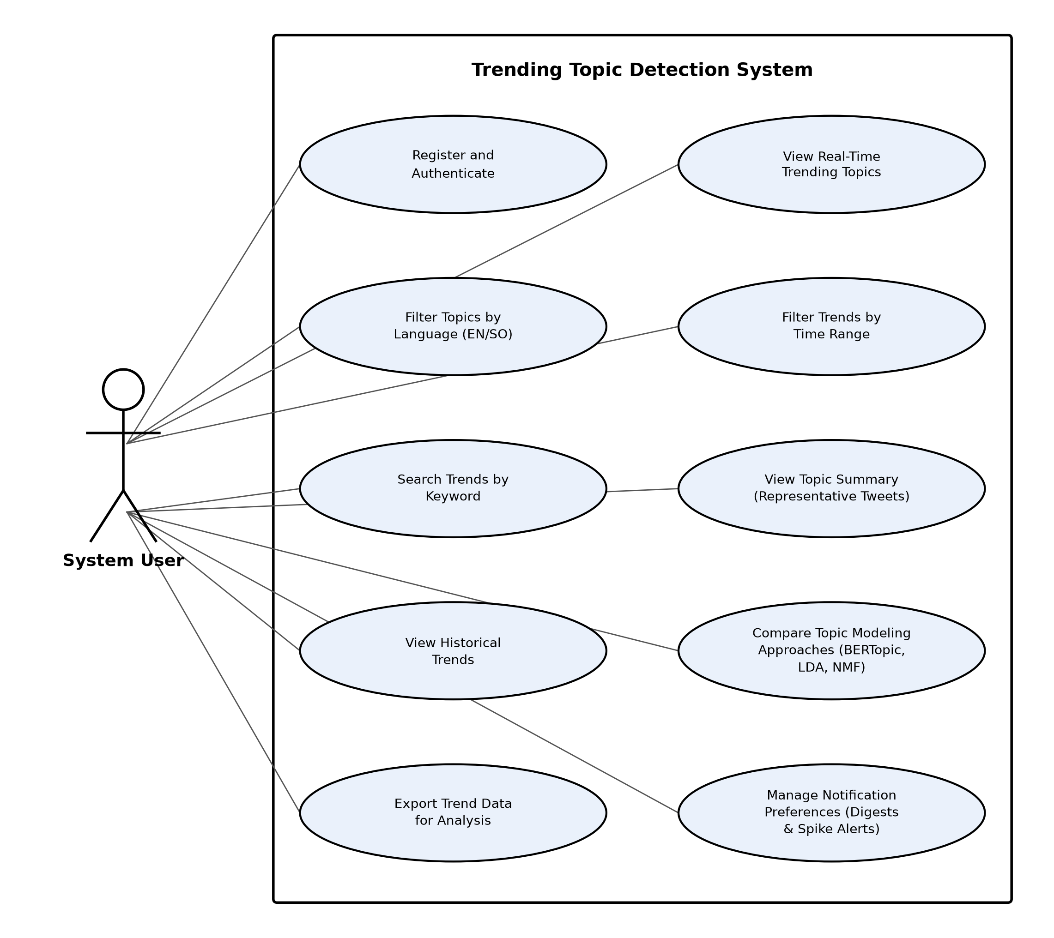
Figure 3.2: Use Case Diagram
Correction Notes
The following notes document how the draft use case list of Section 3.10.1 was verified against the current implementation in the api/ and dashboard/ source trees and corrected accordingly.
Kept unchanged (confirmed implemented):
- View Real-Time Trending Topics — GET /trends (api/app/routes.py); dashboard/src/pages/Trending.jsx, dashboard/src/pages/Dashboard.jsx.
- Filter Topics by Language (English or Somali) — lang query parameter on /trends, /history, and /raw_tweets (api/app/routes.py); ALL/ENGLISH/SOMALI filter buttons in Trending.jsx and Tweets.jsx.
- Filter Trends by Time Range — dashboard/src/components/DateFilter.jsx and DateRangeContext; from_date/to_date parameters accepted by /trends, /history, /raw_tweets, and /models/history (api/app/routes.py).
- View Topic Summary — expandable representative_docs rows in Trending.jsx (explicitly annotated in source as "Use Case 4: View Topic Summary", line 145) and History.jsx; sourced from representative_docs in api/app/routes.py adapt_trend_to_frontend().
- View Historical Trends — dashboard/src/pages/History.jsx; GET /history (api/app/routes.py).
- Export Trend Data for Analysis — dashboard/src/pages/Export.jsx handleExportCSV() and handleGeneratePDF().
Corrected (renamed for accuracy; underlying feature retained):
- “Search Trends by Keyword or Hashtag” → “Search Trends by Keyword”. Reason: POST /filter (api/app/routes.py) matches a case-insensitive keyword regex against the Representation array only; no hashtag field, extraction step, or index exists anywhere in the schema or pipelines, so hashtag search is unimplemented and was removed from the name. Evidence: api/app/routes.py filter_trends(); dashboard/src/pages/Trending.jsx (searchQuery → filterTrends()).
- “Compare Trends Across Languages” → “Compare Topic Modeling Approaches (BERTopic, LDA, and NMF)”. Reason: the Comparison page's defining, purpose-built feature is a three-way model-quality comparison (C_v, U_Mass, and Diversity per model and per language, plus a BERTopic training-run evolution chart), not a cross-lingual trend comparison. It does list English and Somali topics side by side, but that view simply reuses the language filter already covered by “Filter Topics by Language” and is not a distinct comparison feature. Evidence: dashboard/src/pages/Comparison.jsx; GET /models/comparison and GET /models/history (api/app/routes.py); api/jobs/model_comparison.py; api/jobs/evaluation_pipeline.py.
Removed (not implemented or not user-facing):
- “Monitor Topic Growth Over Time”. Reason: the backend defines GET /trends/topics_over_time (api/app/routes.py), which aggregates topic-category volume per day, but no page or component in dashboard/src calls it — the corresponding client function getTopicTrends() in dashboard/src/services/api.js is defined but never imported or invoked anywhere in the dashboard source. The feature is unreachable by a System User and was therefore removed.
- “View Engagement Metrics (tweet count, growth rate)” as a standalone use case. Reason: tweet volume and trend score are genuinely computed and shown (api/services/trend_scoring.py compute_trend_score(); “ENGAGEMENT SCORE” and volume columns in Trending.jsx and Export.jsx), but they are inline data fields of the trending/export tables rather than a separately invoked screen or action, so they are now implicitly covered by “View Real-Time Trending Topics” and “Export Trend Data for Analysis” instead of listed on their own. “Growth rate” specifically is not exposed to the System User at all: the only percentage-change calculation in the codebase is the internal spike-detection threshold in api/services/notifications.py (_detect_spikes()), which drives the spike-alert email rather than an on-screen growth-rate view.
Added (implemented and significant, but missing from the draft):
- “Register and Authenticate (Sign-Up, Login, Google OAuth, Two-Factor Authentication)”. Reason: authentication is a fully implemented precondition for every other use case and was absent from the draft. Evidence: api/app/routes.py — POST /auth/signup, POST /auth/login, POST /auth/google, POST /auth/2fa/send-code, POST /auth/2fa/verify, POST /auth/2fa/disable, POST /auth/change-password; dashboard/src/pages/Login.jsx, Register.jsx; dashboard/src/pages/Setting.jsx (Privacy & Security modal).
- “Manage Notification Preferences (Email Digests and Trend Spike Alerts)”. Reason: users can opt in or out of two distinct notification channels through a dedicated settings screen, backed by working spike-detection and digest-sending logic; this was fully implemented but absent from the draft. Evidence: api/app/routes.py — GET/POST /auth/preferences; api/services/notifications.py — check_and_send_spike_alerts(), send_daily_digests(); dashboard/src/pages/Setting.jsx (Notifications modal — Email Digests and Spike Alerts toggles).

